Erroding Humanity via Artificial Intelligence

Ian Skyles
Institute of Technology
University of Washington - Tacoma
Tacoma, Washington, United States of America
ianskyles@gmail.com

Abstract. Artificial Intelligence will change the world as we know it. It is already displacing millions of jobs worldwide. No jobs will be left unaffected by the continued development of Artificial Intelligence. It is producing many new ethical and moral problems in the sectors of human interaction, physical safety, privacy, anonymity, and moral obligation. We need to plan ahead for all of the changes Artificial Intelligence will bring upon our global civilization.
Keywords: Artifical Intelligence Moral Obligation Job Displacement Human Robot Interaction Philosophy Impoact Life Information Age Impact Privacy Accuracy Accesibility Property Warfare

Introduction
Artificial Intelligence will be replacing millions of jobs; some already replaced jobs include doctors, lawyers, and law enforcement. How do we help replaced workers cope with no job? We need to plan ahead for the many changes AI will cause in our international society. It is hard to globally define an ethical framework for any one problem, especially when it is as broad as Artificial Intelligence. Like an airplane pilot or any successful business, we need to plan ahead to handle the global impact of Artificial Intelligence. We do not have any globally or nationally enforced standards on the development of Artificial Intelligence. If you want to create a recommendation system that directly or indirectly targets low economic class people there is nothing stopping you other than your own moral judgment. If you create something that has a large detrimental effect on the way members of society interact with each other, again, there is nothing stopping you. The problem of governing Artificial Intelligence has yet to be solved. It is a very difficult to solve it as there is no way of enforcing global standards currently. We need to develop methods to protect civilization from the dangers of Artificial Intelligence. AI is an equal threat to humanity as nuclear weapons are to humanity. It might even be worse as it is not currently well governed. We need committees to provide oversight of the work companies, individuals, and governments are doing on Artificial Intelligence.

Related Work

Privacy, Accuracy, Property, and Accesbility
Information and collections of data on people are becoming more valuable by the day. The growth of Artificial Intelligence and electronics are allowing for a mass increase of data on human interaction and human behavior. Arguably the worst and most threatening to humanity is the willingness to collect data even if it means invading a user’s privacy. [1] One important question is who should have a right to data that has been collected, who should be able to collect data, and what permissions they should need to do so? [1] Also, we need to make a decision on who can verify the data collected is accurate and who owns the data: the user or the company who collected the user’s data.

The Right to Privacy
We have a right to the privacy of our thoughts, ideas, and emotions. Property can be intangible or tangible and we ought to have full protection of our property. We ought to have a right to not be gossiped about, and to be left alone. Our privacy can be violated even if we do not suffer any direct or indirect harm. The law should protect users’ information if the community does not have a legitimate concern.

Thin Consent vs Thick Consent
Adam Moore [3] discusses two different standards of consent. Thin Consent is when the user is notified by more or less forced to accept the surveillance and terms of service because they have no other options. An example is a company monitoring an employee’s computers and the employee having no other job options of equal value. Thick Consent is a case where it is a pro user environment and the user could decline surveillance without any consequences. An example is a company monitoring an employee’s computers and the employee having an option to go to another equal company to avoid it being monitored. Surveillance is justified if thick consent is met. [3]

Ethical Risks of Artificial Intelligence
AI has many risks including job automation, too much or too little free time, losing sense of meaning in life, erosion of privacy rights, accountability of an AI agent and its applications, and super intelligence which might be dangerous to the world and humans. [4]

Methodology/Case Study
The invasion of privacy on a mass scale and large numbers of job loss are arguably two of the biggest threats created by artificial intelligence. Recently leaked programs such as NSA’s thin thread have proven that artificial intelligence is being used to monitor mass numbers of people (everyone in the United States and everyone in several other countries). AI has already been replacing many jobs and it is only giving worse. It is leaving a trail of unemployment in its footsteps as it races forward towards light speed advancements in technology.

Privacy
- We see many businesses with models where the users’ data is the product. These include many offerings from major players in the technology industry such as Microsoft (Cortana, Outlook, Edge, and OneDrive), Google (Search queries, Gmail, Drive, and Android), and Facebook (WhatsApp, Instagram, and Facebook.com).
- Artificial Intelligence is often used (to the advantage of the company or government) on data collected from the user. It is used to make determinations about what advertisement to serve a user, aggregate data for a user (for a personalized story), recognize and tag photos with metadata (Facebook and Microsoft facial recognition), driverless cars (Google), predicting search queries, categorizing users cost to a company (insurance or similar), choosing a target for a military strike or watch list, and diagnosing symptoms.
- One threat often overlooked about AI and large collections of data is that databases of information can be used together. One companies garners information A about a user and another Information B. The companies converse and are able to come up with information C about the user via Artificial Intelligence. [1] What is worse is that the growth of new possible connections to be made about a user is exponential.
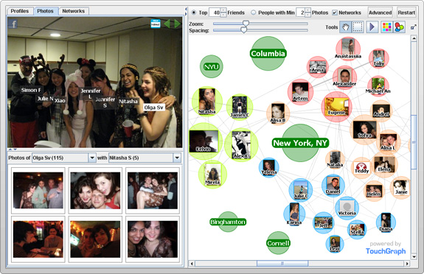
- We should be able to choose who our thoughts, emotions, and ideas are disseminated to. [2] Yet, we seem to be forced to express all of those things to thousands of companies just to do things that are considered part of everyday life. Adam Moore refers to this as “Thin Consent”, when a user has to accept surveillance because it is a tough economy, one in which the resources be it applications, jobs, or opportunities are limited. [3] I’ll use a student attending university to highlight the necessity of waiving one’s rights to their own emotions, thoughts, and ideas. Accessing Canvas by Instructure to submit an essay for class allows companies (Instructure, plagiarism detectors, and anyone either of those wish to sell our data to) to use artificial intelligence on our essays to determine how we were feeling when we wrote it, how we think, what we are likely to do, what are our ideas our for great inventions, and our political beliefs. We must use the internet to research articles and subjects all while being monitored unwittingly. Drawing conclusions about users is one of the largest and most profitable uses of Artificial Intelligence.
Identify applicable sponsor/s here. If no sponsors, delete this text box (sponsors).
Standards need to be established for any and all companies and governments collecting data on its users or citizens. People should be granted as much privacy online as they are granted in their own household. It would not be legal for a company or government (nor would you let them) to come into your home and check every nook and cranny to draw conclusions about you. Why are the internet, our phones, our computers, our online communication and our online storage any different? We need to establish laws that require companies to be more open about the data the collect, require them to offer classes on data privacy and collection, and limit their abilities and what type of data they can collect. If we don’t put protections in place Artificial Intelligence will continue to be used to give companies and governments an unfair advantage against the consumer and earth’s citizens. [2]
One drawback to establishing standards (that should be relatively strict and precise) is a loss of income and monetization for many large companies. The standards should work to allow companies to continue their business of collecting, using, and selling data but in a more open way. Most would probably agree that they would rather have their privacy than a big corporation or government exist solely to profit off of users.
Alternatively, instead of the above we could keep things the way they are now. But, there is a great risk for a continued erosion and invasion of peoples’ privacy. We could let companies govern their own data collection and allow people to vote with their application use, consumption of products, and money invested in companies.

Job Loss
Artificial Intelligence is replacing jobs like no other technology before it has. It does create new jobs in high tech industries such as computer science, data science, machine learning, and Artificial Intelligence. But, their will eventually be far more jobs destroyed if you will than there will be created.
Examples of jobs being replaced by Artificial Intelligence are widespread.
- Lawyers are being replaced by ROSS, a legal artificial intelligence system that monitors laws for changes that affect cases, offer simple advice on legal issues, and provide relevant cases related to legal issues you may be having.
- Doctors are being replaced by WebMD, a medical diagnosis tool that uses AI to diagnose a condition based on age, gender, and symptoms.
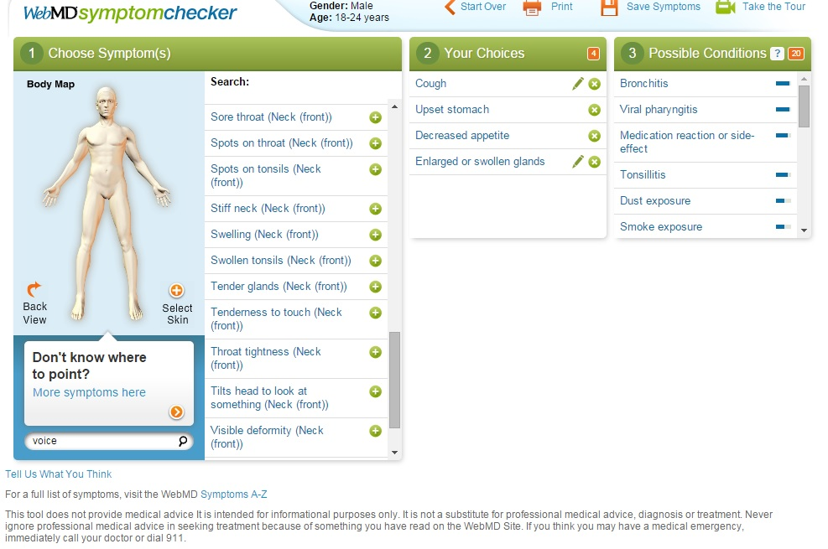[8]
- Police are being replaced by traffic and stoplight cameras that monitor drivers to ensure road safety.
- Taxi, Uber, and Lyft drivers are in the process of being replaced by driverless cars. Driverless cars will likely replace a lot of airplane pilots when people opt to take a driverless car cross country instead of a plane.
- Fast food employees are being replaced by automatic ovens, ordering, and serving robots.
- Maids have been replaced by Roomba and lawn maintenance crews replaced by similar technology.
- Factory works have been replaced by robots and Amazon’s Kiva technology which transports pallets of goods around a warehouse.
- Companies like LinkedIn are making finding employees much easier. They allow recruiters to tap a large network of potential candidates and very quickly find someone who has the skills needed for a job. Riminder, a new startup, uses artificial intelligence to analyze CVs. They analyzed 2 million career paths to help figure out which candidates will be successful. Employing technologies from LinkedIn and Riminder, companies can hire much quicker and more efficiently. By doing so, they are able to vastly reduce the number of head hunters they need to employ. According to the BLS, recruiters (human resource specialist) are projected to only have 5% job growth over the next 10 years. The average growth rate of all occupations is 7%. The site says that human resources specialists will be replaced by new technologies [10] which are using artificial intelligence as the underlying structure.
More jobs will be replaced as Artificial Intelligence gets better over time. As we can already see, no job is safe. Even doctors, what most considered being one of the most skill demanding professions which often requires five or more years of education, have been replaced by AI.
The main problem with the above is that we have no system in place to help displaced workers. With approximately 45% of jobs in an at risk category to being replaced by Artificial Intelligence in the next two decades, we need to come up with a system to support the high levels of unemployment which might occur. [6] It is easy to imagine a very quick change in the employment sector. For example, maybe McDonald’s automates all of their ordering in the United States of America. This would result in hundreds of thousands of displaced employees.
One solution to the problem is to require companies who displace workers to require training to them until they are employable in a not yet automatized position. This solution is surely naïve because it would stunt the growth of artificial intelligence.
Another option is to offer free training programs to the displaced workers via the government. This seems to be a great option as it would benefit all citizens of the government. The training could include a free or subsidized college education. Citizens, who have a college education volunteer more, pay more in taxes, less likely to use federal and state benefits such as SNAP, and make more money. [7]
A final option is to do nothing to help the displaced workers. This seems to be the least ethical option. Although, there are, with the creation and expansion or Artificial Intelligence, many free avenues to getting an education which would make one competitive in the 21st century. Some options include Udacity, EdX, and Coursera.
Regardless of the option societies or sub societies choose to take, it should be one that allows the equal benefit of artificial intelligence. It is the responsibility of governments, scientists, developers, and citizens who govern and use the new technology to ensure that artificial intelligence benefits are distributed equally with justice and fairness. [7]

Conclusion
This paper has only touched on a few of the dangers that artificial intelligence poses to humanity. It is quite easy to think of many more threats not listed which generate from AI. After exploring the inevitable job loss and privacy concerns caused by AI, it seems that we need to develop methods for protecting humanity from AI while still reaping the gigantic package of benefits it can offer. The United States Department of Health and Human Services is a government organization that funds and oversees many programs which regulate industries. These industries include healthcare, disease control and prevention, food and drugs, childcare, education, and public health. The USA has other programs that regulate education and yet another for war. It seems necessary that we initiate a board and department to regulate and oversee artificial education to ensure the health, safety, prosperity, and freedom of Americans. Other countries could follow suit. A large alliance similar to the North American Treaty Organization could be formed to rally inter country commitment and cooperation on the over watch of the dangers of artificial intelligence be it privacy, replacing jobs with robots, warfare, human interaction, and or the human race in general. AI over watch should be open sourced to ensure that all AI developers are moderated and follow whatever newly developed rules which are formed by the coalition.

References
The following sources have been used to research the topic, support possible solutions to the problem, support statements in the paper, and provide graphic images to enhance the readers’ experience.
- Mason, Richard O. “Four ethical issues of the information age.” Mis Quarterly (1986): 5-12.
- Warren, Samuel D., and Louis D. Brandeis. “The right to privacy.” Harvard Law Review, Vol. 4, No. 5 (1890): 193-220.
- Moore, Adam D. “Employee monitoring and computer technology: Evaluative surveillance v. privacy” Business Ethics Quarterly 10.03 (200): 697-709.
- Russel, Stuart, and Peter Norvig. “Artificial intelligence: A Modern Approach.” (2003): 960-967.
- Altman, Russ., and Veloso, Manuela. “Ethics of artificial intelligence” Nature, Vol. 521, Number 7553. (2015): 417-418
- Frey, Carl Benedikt, and Michael A. Osborne. "The future of employment: how susceptible are jobs to computerisation." (2013): 44-45.
- Baum, Sandy, Jennifer Ma, and Kathleen Payea. “Education Pays 2013 – The Benfits of Higher Education for Individuals and Socity.” College Board Online. (2013)
- Screenshot(2016).WebMD.com
http://symptoms.webmd.com/default.htm#symptomsView
- Screenshot(2016).TouchGraph.com http://www.touchgraph.com/popup/facebook-photo-04
- Human Resources Specialists Job Outlook.
http://www.bls.gov/ooh/business-and-financial/human-resources-specialists.htm#tab-6

